OpenCart Website
Tutorial 10 — Automation Feasibility & Regression Testing
Module Name: OpenCart Website – Automation Feasibility & Regression
Report ID: TR10_001
Webpage URL: https://demo.opencart.com

Aim
To identify OpenCart test cases suitable for automation and to execute a regression test suite on the website.

Parameter Details
Module Name | Login, Registration, Search, Navigation, Logout
Project Name | OpenCart Website Testing
Application | OpenCart (opencart.com) – executed on the official demo store, demo.opencart.com
SDLC Model | Waterfall Model
Automation Tool (proposed) | Selenium (alt: Playwright, Cypress)
Test Environment | Windows / Google Chrome
Tester Name | Student Name
Test Date | 15/08/2026

Test Cases
TC ID | Scenario | Input | Expected Result | Actual Result | Status
RT001 | Login – Valid Login | Username demo + correct password | Login successful; Dashboard opens | Login successful; Dashboard opened | Pass
RT002 | Registration – Register page validation | Submit Register form with invalid / empty input | Required-field / invalid-input messages shown | Register form displayed; validation not captured | Not Executed
RT003 | Search – Search existing product | Search "Macbook" | Matching results displayed | 3 matching products listed (MacBook, MacBook Air, MacBook Pro) | Pass
RT004 | Navigation – Open site pages | My Account -> Login, Register; footer -> Contact Us | Every page loads correctly | Login, Register and Contact Us pages loaded correctly | Pass
RT005 | Logout – Logout | Profile menu -> Logout | Return to Login page | Administration Login page displayed | Pass

Automation Candidate Test Cases
TC ID | Functionality | Automate? | Reason | Tool
TC001 | Login | Yes | Frequently executed | Selenium
TC002 | Registration | Yes | Stable, repetitive validation | Selenium
TC003 | Search | Yes | Repetitive operation | Selenium
TC004 | Navigation Menu Links | Yes | Simple repetitive check | Selenium
TC005 | Logout | Yes | Simple repetitive task | Selenium
TC006 | Marketplace Listings Content | No | Content changes frequently | Manual Testing
TC007 | Download Page Details | No | Version info changes each release | Manual Testing

Execution Evidence
RT001 — Login: Valid Login
Steps
- Open the administration login page.
- Enter username "demo" and the correct password.
- Click Login.
Expected Result: Login successful; Dashboard opens
Actual Result: Administration Dashboard opened.
Status: Pass
Screenshot:
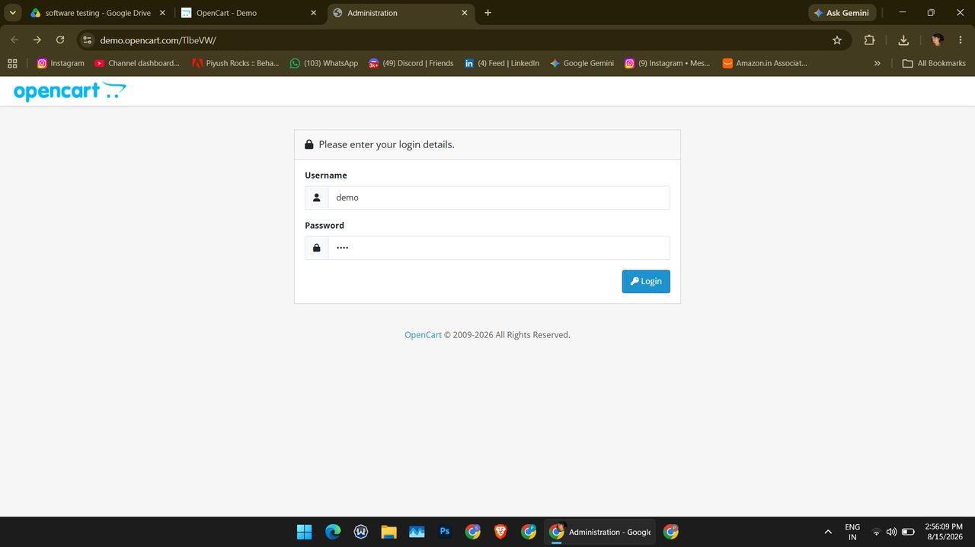
Screenshot (131)
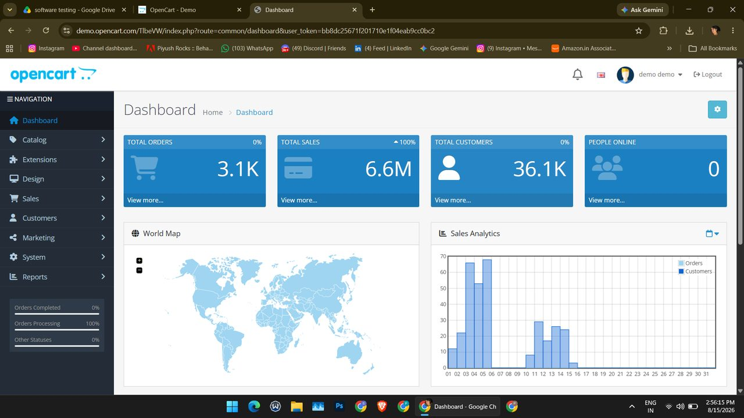
Screenshot (132)
RT003 — Search: Search existing product
Steps
- Open the demo store home page.
- Type "Macbook" in the search box and press Search.
Expected Result: Matching results displayed
Actual Result: Search – Macbook page listed 3 products (MacBook, MacBook Air, MacBook Pro); "Showing 1 to 3 of 3 (1 Pages)".
Status: Pass
Screenshot:
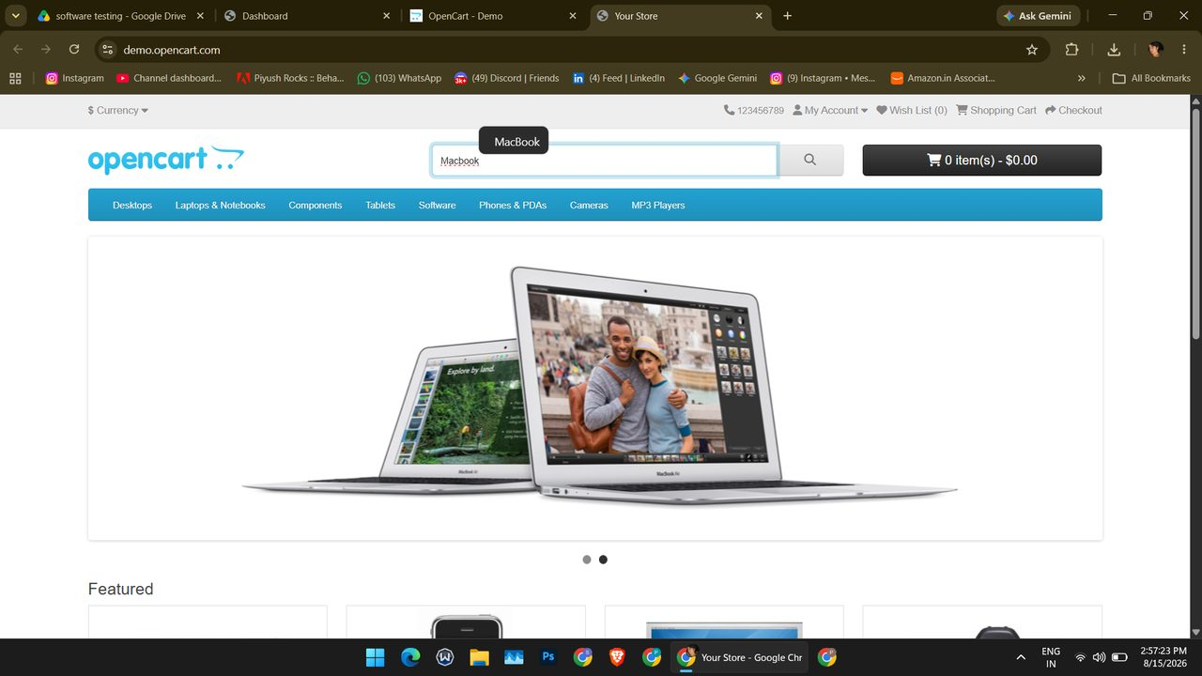
Screenshot (135)
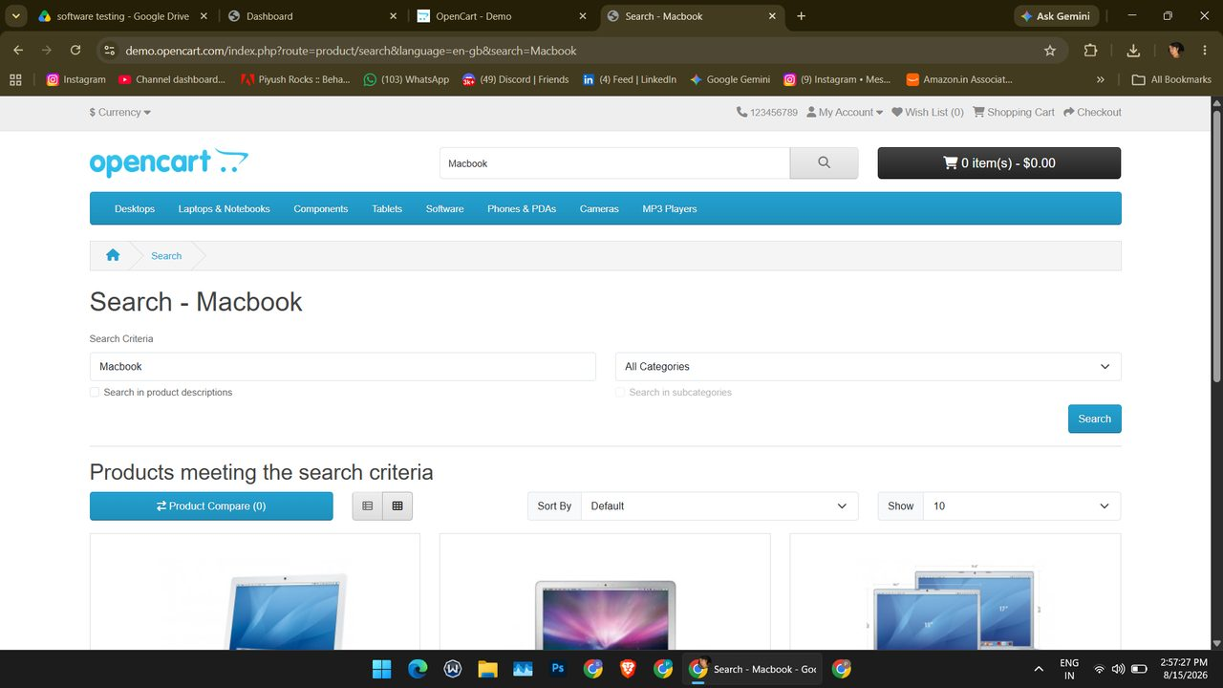
Screenshot (136)
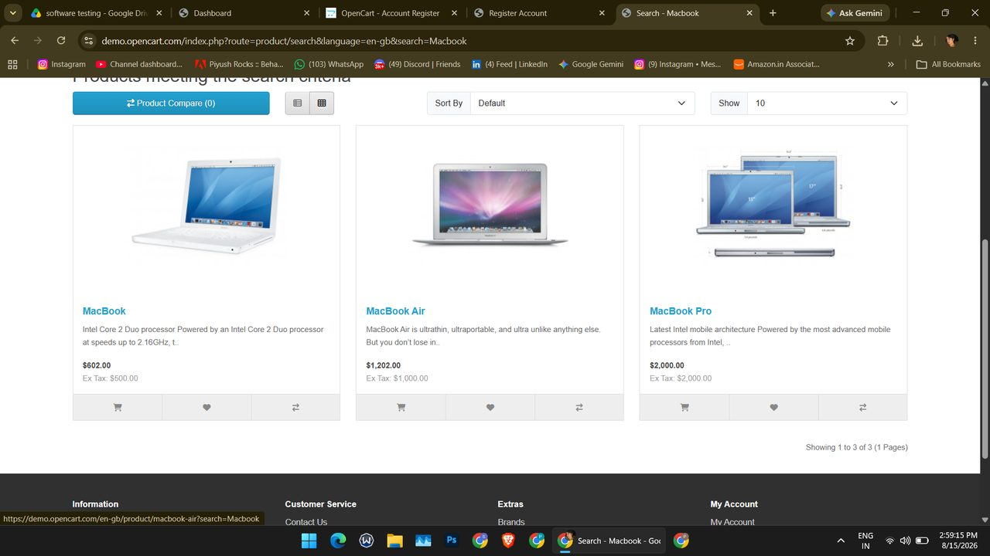
Screenshot (142)
RT004 — Navigation: Open site pages
Steps
- Click My Account and choose Login.
- Choose Register from the same menu.
- Open Contact Us from the footer.
Expected Result: Every page loads correctly
Actual Result: Login, Register and Contact Us pages loaded correctly.
Status: Pass
Screenshot:
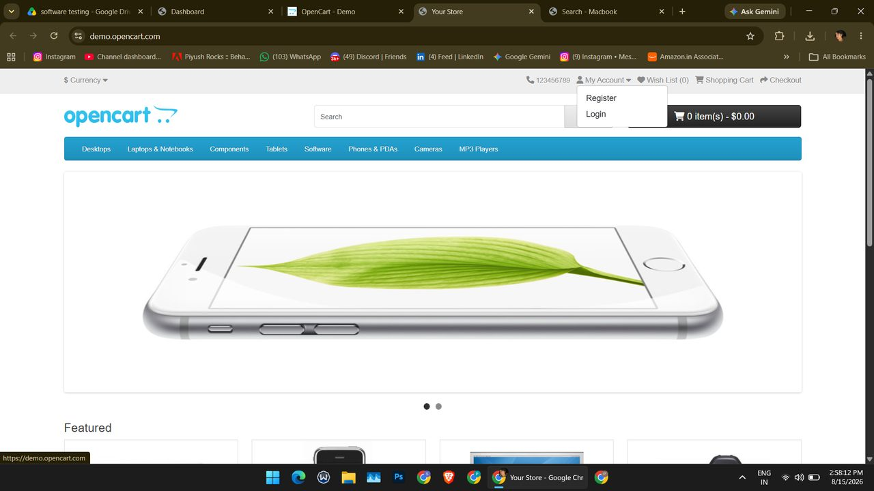
Screenshot (139)
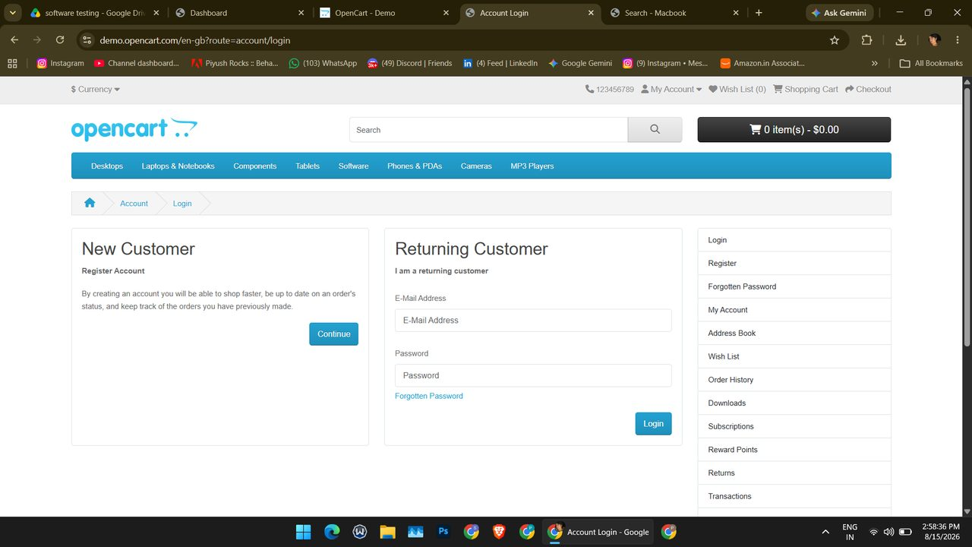
Screenshot (140)
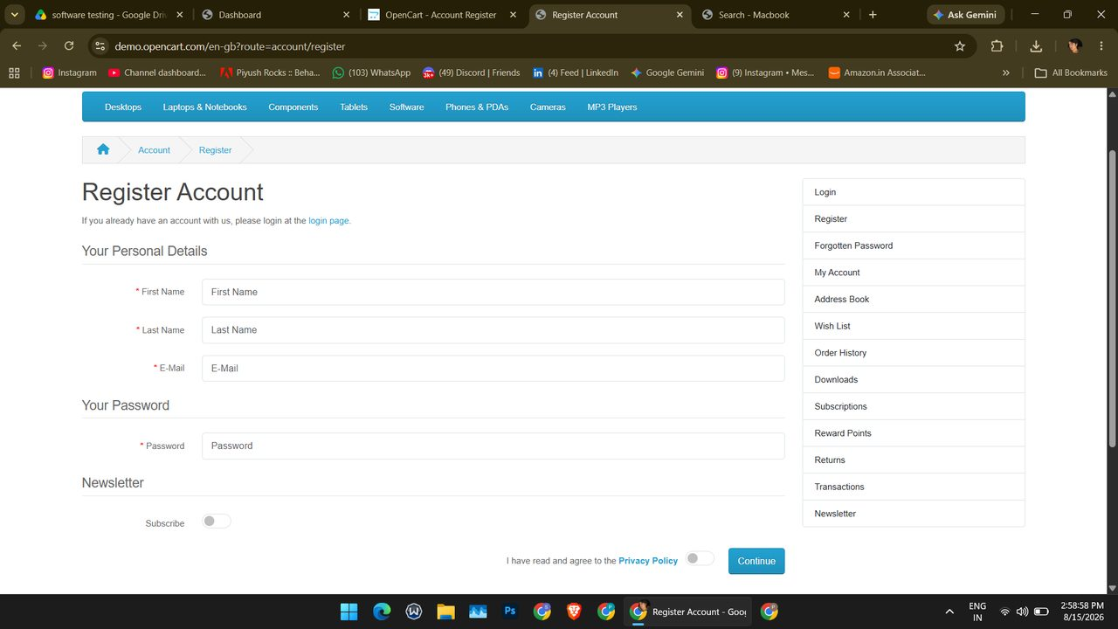
Screenshot (141)
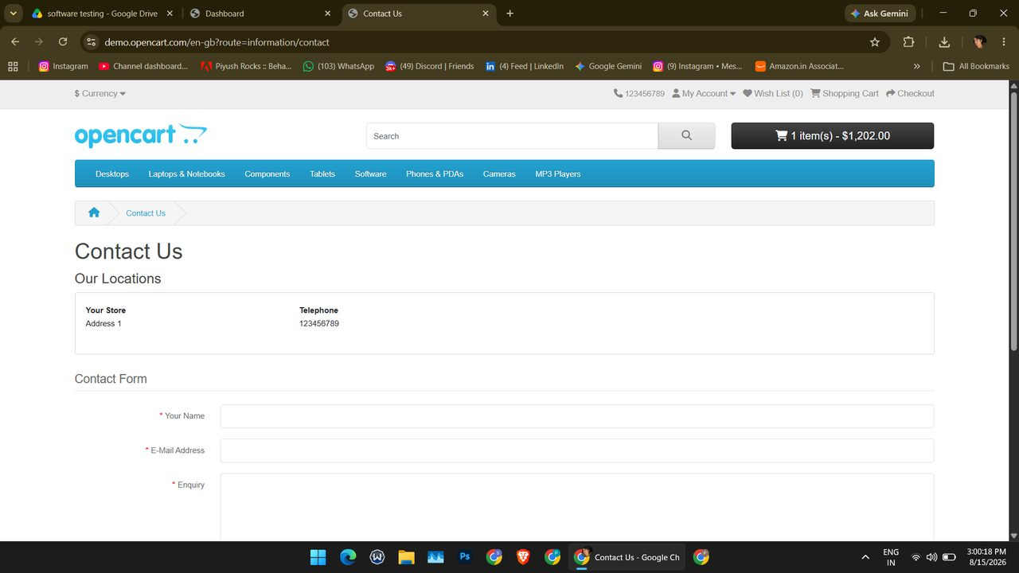
Screenshot (148)
RT005 — Logout: Logout
Steps
- From the Dashboard open the profile menu and click Logout.
Expected Result: Return to Login page
Actual Result: Administration Login page displayed.
Status: Pass
Screenshot:
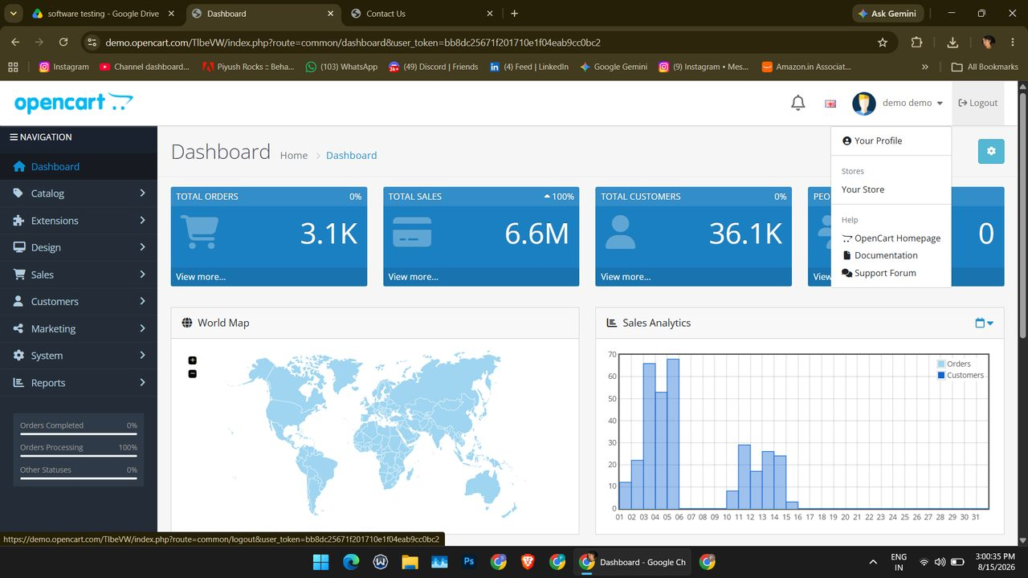
Screenshot (149)
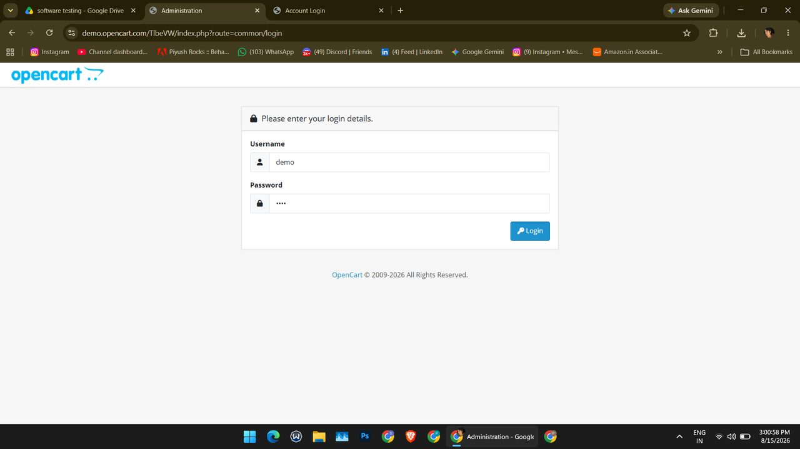
Screenshot (151)

Summary of Execution
Metric | Value
Total test cases | 5
Executed (Pass + Fail) | 4
Passed | 4
Failed | 0
Blocked | 0
Not Executed | 1
Pass % of executed | 100.0%
Pass % of total | 80.0%
Automation candidates (Yes / No) | 5 / 2
Automation candidates % | 71.4%
Recommended tool | Selenium (alt: Playwright, Cypress)

